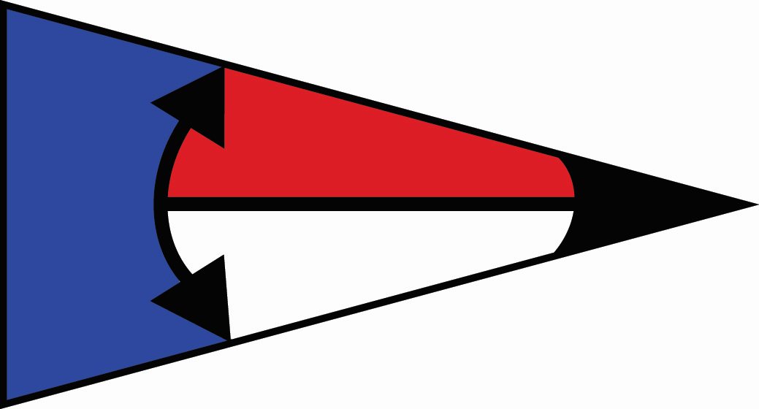
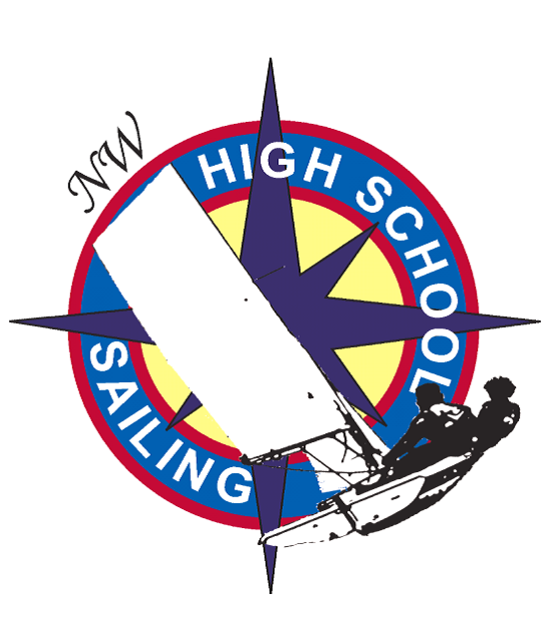
Islands Cup

Oak Harbor, WA 98277

April 8-9, 2017

RULES

The regatta will be governed by the Racing Rules of Sailing for 20013-2016, the prescriptions of US SAILING, the ISSA Procedural Rules, this Notice of Race, and the Sailing Instructions. However,

The US Sailing prescriptions to rules 60, 63.2, and 63.4 will not be in effect; and

Under rule 70.5(a), the right of appeal is denied

ELIGIBILITY

Current ISSA and NWISA membership is required and will be verified at the time of final registration at the regatta site.

A responsible adult leader must accompany teams at all times

Teams for varsity (“gold fleet”) shall be comprised of a minimum of 4 and a maximum of 8 sailors who are full time students in the 9th grade or higher, attending the same high school.

There are no numerical or age restrictions, or school restrictions on junior varsity (“silver fleet”) competitors.

ENTRY AND COMMUNICATIONS

Eligible schools shall fill in the appropriate sections of the NWISA Registration spreadsheet, their intent to participate, number of additional boats, and total number of sailors attending no later than 3/31/2017.

Teams unable to compete shall notify the Regatta Chair as soon as possible.

Entry fee includes lunch/dinner Saturday April 8, and breakfast/lunch Sunday April 9.
Entry Fee: $20 per person
Damage Deposit: $250.00 per team must be on deposit with NWISA
Make checks payable to: Oak Harbor Youth Sailing

3.4 Registration opens March 27, 2017 at 11:00am. Eligible schools shall submit their intent to participate, total number of sailors attending and number of boats they can bring to the NWISA registration spreadsheet no later than April 3, 2017 at 10:00pm. Additional registrations are allowed after this time, but teams may be turned away if boats are unavailable. There will be no morning of registration.

BOATS

Races will be sailed in FJs

All boats will be inspected by regatta chair or designee prior to launching.
4.3 Teams should plan to bring additional boats if possible.

SCHEDULE
Saturday, April 8, 2017
0830 Report Time, Rigging and Final Registration – make lunches at OHYC
1000 Competitors Meeting
1030 First Warning: Racing will continue throughout the day.
Eat during boat rotation – no lunch break.
Racing will continue until late, weather permitting and daylight permitting.
1800 Dinner Served
1900 Live music at the OHYC until 2100
2000 Doors open at OHHS for overnight lodging

Sunday, April 9, 2017
0800 Report Time – Breakfast served until 9:00 and make lunches at OHYC
0830 Doors close at OHHS lodging, no access to building after this time
1000 First Warning: Racing will continue throughout the day.
Eat during boat rotation – no lunch break.
1500 No Warning after this time, except for tie-breakers
1630 Awards presentation, or after completion of racing.

Any changes to the schedule will be posted on the Official Notice Board.

RACING AREA

The racing area will be West of Oak Harbor Marina breakwater.

Rotations for both fleets will be located on E dock, or in the case of South East wind, a floating dock to the West of OH Marina breakwater.

COURSES

Based on conditions, the Race Committee will determine the courses. Short collegiate style courses will be used.

SCORING

The regatta will be scored in accordance with ISSA Procedural Rules.
8.2 This regatta is a Qualifying Regatta as defined by the NWISA District Supplemental Rules. Qualifying regattas may be attended by active or mixed teams. However, final scores by mixed teams or additional active teams (JV teams) will be removed from the official results and the regatta will be re-scored. For schools sending multiple Active teams, a Varsity team must be designated at registration. This Varsity team will be the team scored in the overall rankings for our Double-handed Fleet Race District Championship.

FORMAT

The format will consist of two races in A division, followed by boat rotation, and two races in B division.
9.2 Racing will take place on one course, with two separate starts. One for Gold Fleet, and one for Silver Fleet.

LODGING

Housing is available at the Oak Harbor High School gymnasium/mat room on Friday April 8 if needed, and Saturday April 9, contact Erik Mann at emann@windermere.com for more information.

You must provide your own sleeping bag and pillow.

Each team is responsible for supervising their sailors at all times during the regatta and while at provided housing. At least one adult must accompany each team while on campus of OHHS.
10.4 Bathrooms and showers are available at the OHHS gymnasium, students need to bring their own towels, personal items, etc.

TRAVEL

Directions to sailing venue from I-5 can be found at https://goo.gl/maps/ZvN1vm2wvNL2.

Directions to sailing venue from Port Townsend to Keystone ferry can be found at https://goo.gl/maps/KWvqcFg1TEJ2.
11.3 Directions to OHHS overnight lodging from sailing venue can be found at https://goo.gl/maps/7fiicwT7ba62.

COACHING

Team leaders, chaperones, coaches, parents, advisors and other support personnel shall not go afloat in the sailing area from the start of racing Saturday to the end of racing Sunday UNLESS an exception has been explicitly permitted by the regatta chair or PRO.

Competitors may receive coaching including instructions, assistance, equipment or sustenance only while on the designated rotation float or on shore.

PRIZES

Prizes will be awarded to the teams placing first, second, and third in Gold and Silver fleet.

OFFICIAL NOTICE FOR ALL PARTICIPANTS

No contestant shall use, either on or off the water, alcoholic beverages (beer, wine, distilled spirits), or use any controlled substance (marijuana, cocaine, etc.), the possession of which is unlawful. An alleged breach of this rule and/or other disciplinary matters that occur may be the basis for a hearing under rule 69.1. The protest committee for such a hearing will be the Regatta Chairperson, a member of the NWISA Board of Directors and the chairperson of the protest committee.

REGATTA CONTACTS
Regatta Chair: Erik Mann. (360) 632-6572 – emann@windermere.com

Sailor Name: _____________________________________ School Name: ________________________

WAIVER OF LIABILITY/RELEASE OF RISK
Oak Harbor Youth Sailing
2017 NWISA Regattas

As the parent/guardian of the above named student, I hereby acknowledge that Sailing is an activity that has an inherent risk of damage and injury. Competitors in this event are participating entirely at their own risk. See RRS 4, Decision to Race. The ISSA, NWISA and race organizers (Oak Harbor Youth Sailing, Oak Harbor Yacht Club, Oak Harbor Marina, race committee, sponsors, or any other organization or official) will not be responsible for damage to any boat or other property or the injury to any competitor, including death, sustained as a result of participation in this event. By participating in this event, each competitor agrees to release the ISSA, NWISA and race organizers form any and all liability associated with such competitor’s participation in this event to the fullest extent permitted by law.

Date: ____________

Signature: __________________________________________

Print Name: ________________________________________

Relation to Named Student: ____________________________

